# Assessment Brief

An automotive company is developing a new prototype arm to help automate and streamline the painting of designs on a vehicle. The robot will be required to draw shapes at a fast pace and with high accuracy. As part of the robotics team, your work will be divided into two parts:

* build a robot and design advanced controllers.
* write a report concluding on the results.

## Part I: Robot control

### Hardware

Firstly, you must assemble the robot, a list of components is shown below as well as an exploded view of the prototype. A simplified wiring diagram is also attached in the references.

|  |  |  |
| --- | --- | --- |
| No. | Component | Quantity |
| 1 | Geared 122 rpm DC Motor with Encoder | 4 |
| 2 | Joint Bearings | 4 |
| 3 | Turntable bearing | 1 |
| 4 | 6mm Motor shaft connector | 4 |
| 5 | Aluminium brackets | 6 |
| 6 | Pen holder clip | 2 |
| 7 | Aluminium extrusion 300mm | 4 |
| 8 | Aluminium extrusion 100mm | 5 |
| 9 | Metal corner brackets | 10 |
| 10 | Maker beam nuts/bolts | 30 |
| 11 | M3 10mm socket bolts/ nuts | 31 |
| 12 | M3 6mm CS socket screws | 16 |
| 13 | M5 16mm CS bolts/nuts | 4 |
| 14 | Arduino Mega 2560 + cables | 1 |
| 15 | L298N Driver | 2 |
| 16 | Male-Male 200mm jumper wires | 40 |
| 17 | Female-Male 200mm jumper wires | 40 |
| 18 | Breadboard | 1 |
| 19 | Microswitch | 6 |

### Software

Using an Arduino microcontroller, you must design controllers to make the robot follow a trajectory. These controllers may range from linear control techniques to multivariable and non-linear techniques. To get used to the C programming language, some references and sample codes are linked to the brief. (Code must be written in C and no external libraries may be used.)

### Risk register

A risk register is provided, and each risk is evaluated based on its severity and likelihood.

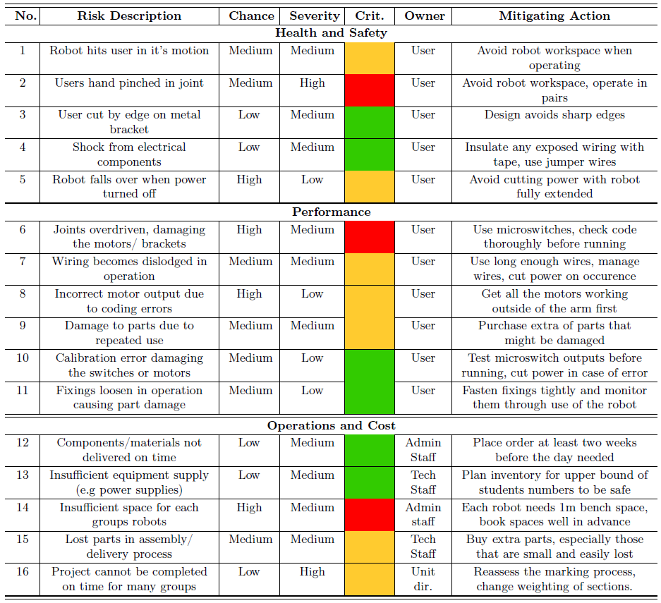

### Task Description

The robot will be assessed on the accuracy and speed required to complete the tasks listed below. The robot should complete the following tasks autonomously, with no further handling from you.

1. Straight line
2. Arc
3. Segment
4. Circle
5. Square
6. Spiral
7. Star

These shapes should be drawn on a sheet of A4 paper which will be scanned and uploaded through blackboard. A video of the operation of the robot should also be submitted alongside the code developed.

## Part II: Control system analysis

Drawing from the work developed in Part I, you must conduct a scientific review of the work you have done. This will be assessed in the form of a 10-page written report. Using your critical insight, form a hypothesis which will be discussed via the analysis of your results. Your report should include:

* A quick overview of the control techniques and the methodology used.
* A comparative analysis of non-linear and multivariable control with linear control and their limitations.

Your ability to create a scientific experiment, conduct the experiment and communicate the result will be representative of your understanding of control systems and robotics. Your report should effectively communicate:

* The problem and aims, and why it is significant.
* The methodology used during the experiment.
* The results of the control system and its performance.
* A discussion and evaluation of these results.
* A conclusion reflecting on the aims initially presented.

## Video submission

A video submission is required for Part I as evidence of the performance of the control system. The following rules are required:

1. The video must be a single take and unedited.
2. The video must focus on the code used to be compared to the code uploaded to blackboard.
3. During the operation of the robot, the manipulator must be always in clear view.
4. Once the robot has stopped its operation, the video must zoom in on the shape drawn to be compared with the shape submitted via blackboard.

## Report marking criteria

The written report be marked according to the 21-point scale.

## References

[Speed & Position Control – DC Gear Motor with Encoder | MOT 6](https://www.youtube.com/watch?v=QpqczRkkfB0&ab_channel=EEforEveryone)

Sample codes are attached in the Github